# Month End closing

## Exporting the main sheet for closing

* Open the **“Cost Revenue ASR Analysis Monthly Report”**
* Select the month for which closing has to be done.
* Level 1: Direction
* Level 2: Account

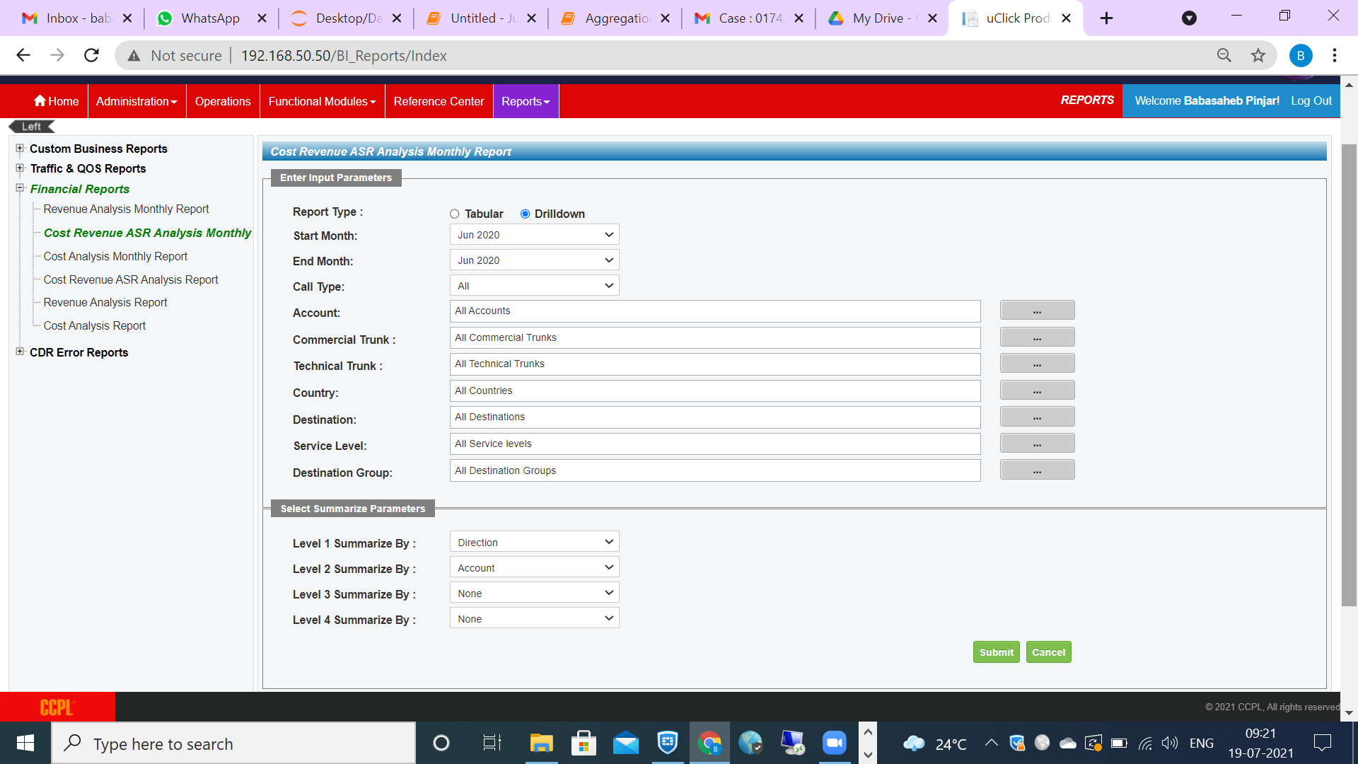

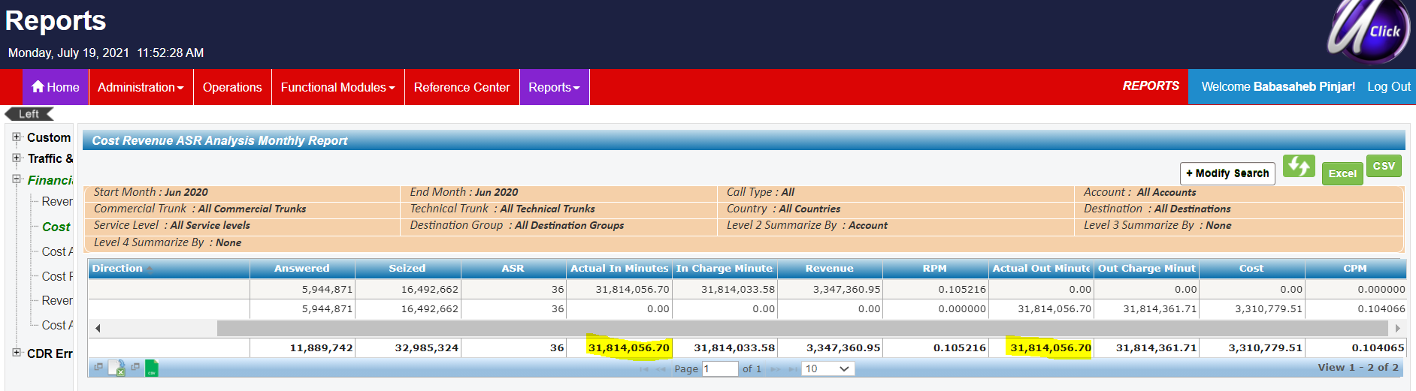

Here we compare “Actual in Minutes” and “Actual Out Minutes”, they should be same.

“In Charge Minutes” and “Out Charge Minutes”, they will not be the same (due to rounding rules on the outbound side, we might see some change but the variation should be minimal.

Export it to “Excel”.

Now, in the excel sheet downloaded (CostRevenueAsrMonthly-xxxxx.xslx) we have both inbound and outbound minutes. We will now separate inbound and outbound minutes in two different sheets.

Delete first 11 rows

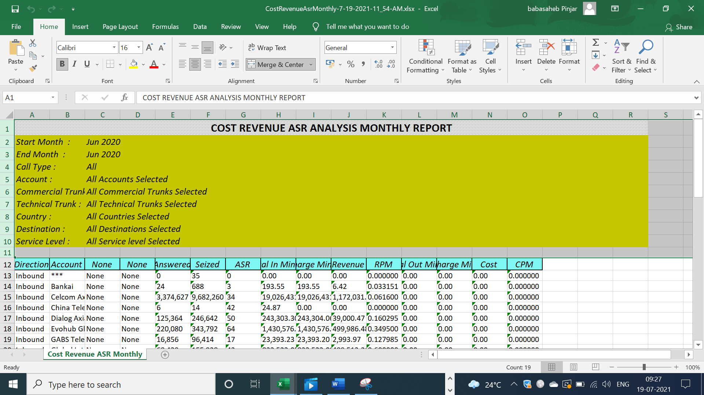

Create 2 sheets for inbound (Select Direction = Inbound in the main sheet) and outbound (Select Direction = Outbound in the main sheet)

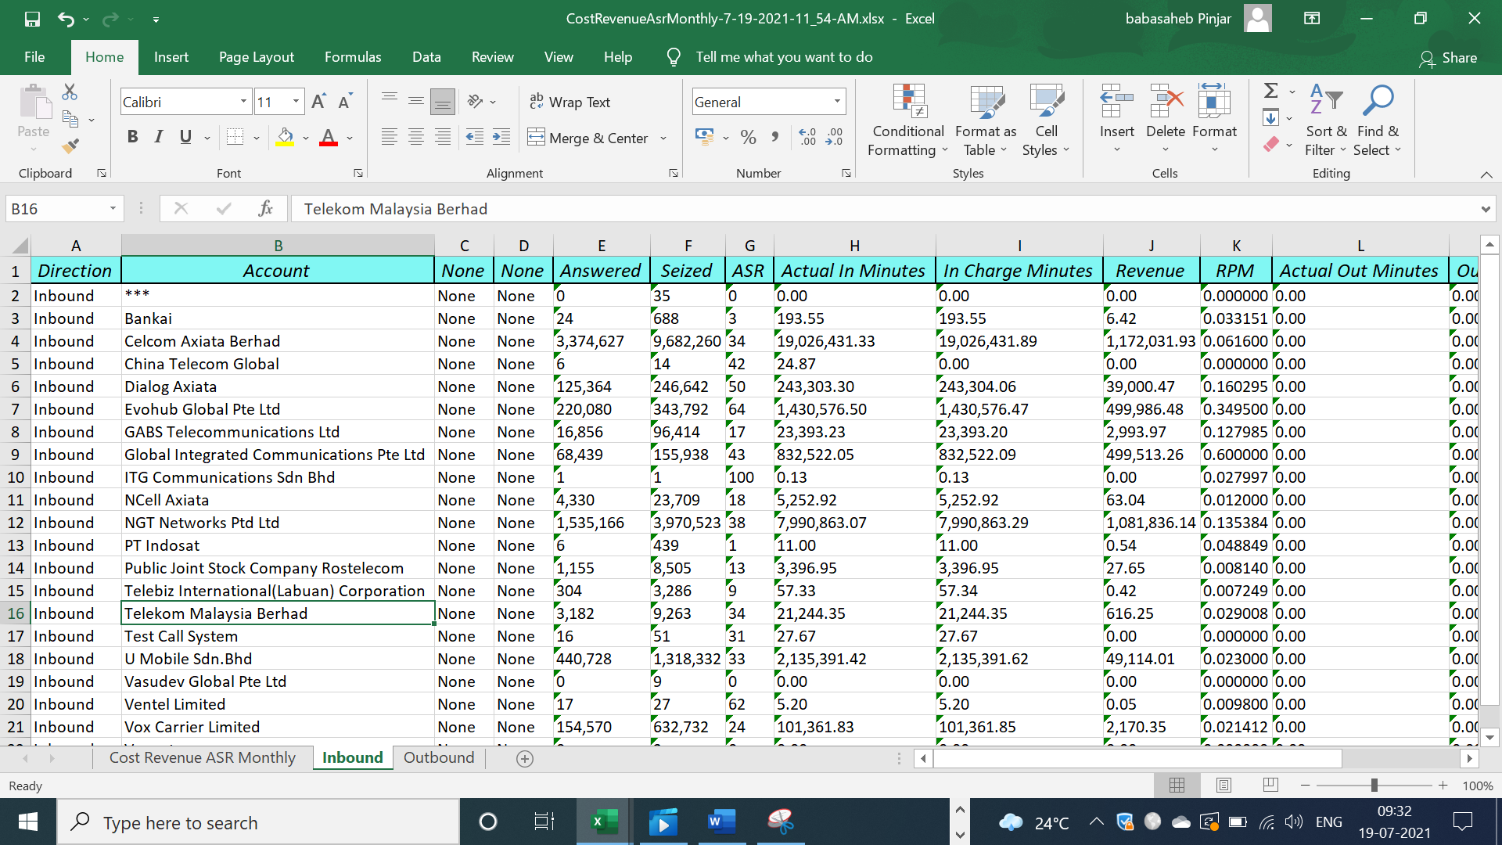

## Creating Inbound Sheet

* Delete columns C and D which are None (Not required).
* Actual Out Minutes, Out Charge Minutes, Cost and CPM columns can be deleted in the inbound sheet

Now in the **Inbound** sheet we select **“Answered = 0”** and delete them since they don’t add any value. Delete 3 rows showed in the below picture

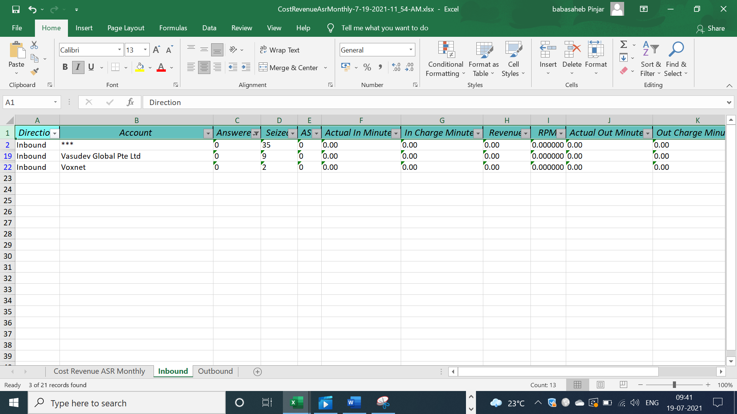

* We will check if there are any Accounts for which “**Revenue = 0**”, if present then we will not consider them for closing as well. But before deleting them from the sheets we have to check why the “Revenue” is not there for the accounts.

The reasons might be

* + Test account system
  + Test calls (Confirm from AGS account manager)

Eg: There are 3 accounts for which “Revenue = 0”, we will delete these as well.

CTG: Test calls

Test Call System: Have to be deleted

ITG: There are In and Out minutes but due to rounding the Revenue is 0 so its negligible.

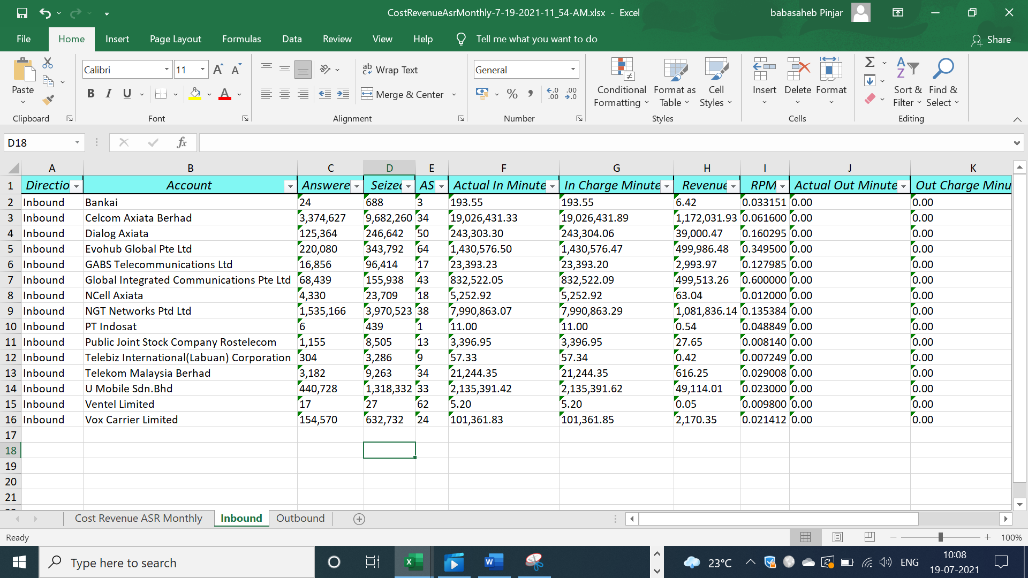

Now the “Inbound sheet is ready”

## Creating Outbound sheet

* Delete columns C and D which are None (Not required).
* Actual In Minutes, In Charge Minutes, Revenue and RPM columns can be deleted in the outbound sheet

Now in the **Outbound** sheet we select **“Answered = 0”** and delete them since they don’t add any value. Delete 4 rows showed in the below picture

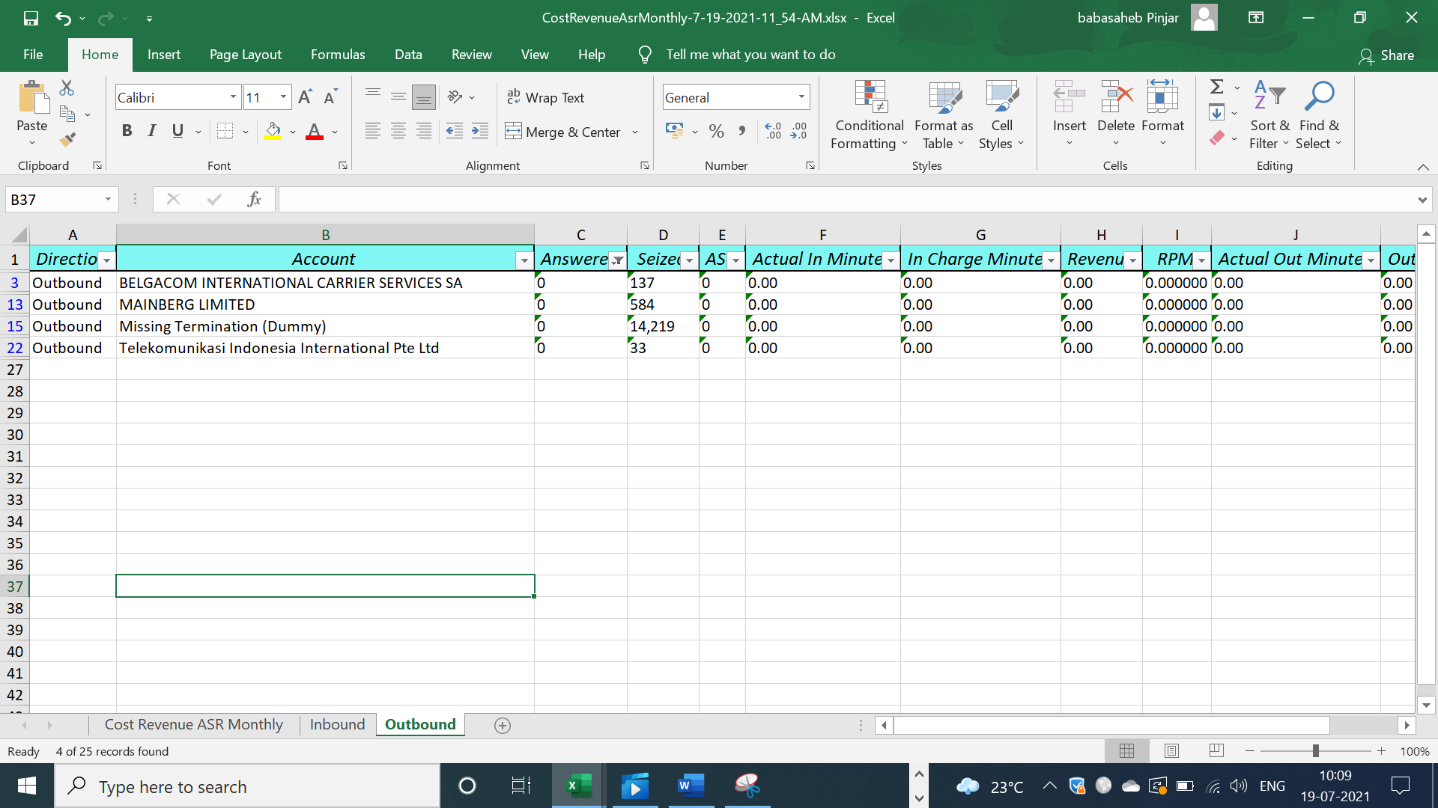

* We will check if there are any Accounts for which “**Cost = 0**”, if present then we will not consider them for closing as well. But before deleting them from the sheets we have to check why the “Cost” is not there for the accounts.

CTG: Test calls, so will be deleted from the sheet

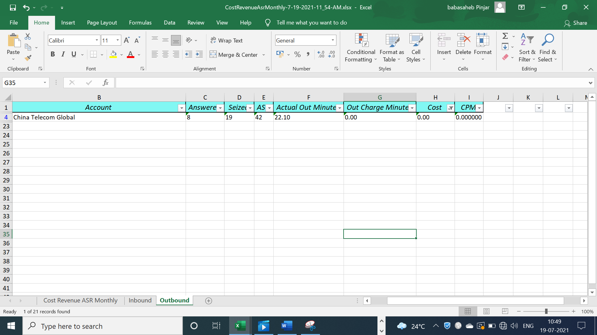

Now the “Outbound sheet is ready”

## Generating Statement numbers

We have to generate 4 types of statements

* + 1. IB: Normal Inbound partners, Axiata non-related parties
    2. IBRP: Axiata related partners (Celcom, Dialog, NCell,Smart)
    3. SOU: Prepaid

The below SQL code will generate the statement numbers for all the above 3 types.

Declare @StatementPrefixInbound varchar(100) = 'SSG2/IB/SOU/'

Declare @StatementPrefixOutbound varchar(100) = 'SSG2/OBRP/'

select isnull(@StatementPrefixInbound +

right('00000000' + convert(varchar(10),(max(convert(int ,substring(StatementNumber, len(@StatementPrefixInbound) + 1 , len(StatementNumber)))) + 1)) , 8)

, @StatementPrefixInbound +'00000001')

from

(

select RevenueStatement as StatementNumber

from Reportserver.UC_Report.dbo.tb_BillingAccountInfo

where RevenueStatement is not NULL

and isnumeric(substring(RevenueStatement ,len(@StatementPrefixInbound) + 1 , len(RevenueStatement))) = 1

union

Select StatementNumber

from Referenceserver.UC_Reference.dbo.tb_AccountReceivable

where StatementNumber is not NULL

and isnumeric(substring(StatementNumber ,len(@StatementPrefixInbound) + 1 , len(StatementNumber))) = 1

) tbl1

where substring(StatementNumber , 1 , len(@StatementPrefixInbound)) = @StatementPrefixInbound

select isnull(@StatementPrefixOutbound +

right('00000000' + convert(varchar(10),(max(convert(int ,substring(StatementNumber, len(@StatementPrefixOutbound) + 1 , len(StatementNumber)))) + 1)) , 8)

, @StatementPrefixOutbound +'00000001')

from

(

select CostStatement as StatementNumber

from Reportserver.UC_Report.dbo.tb_BillingAccountInfo

where CostStatement is not NULL

) tbl1

where substring(StatementNumber , 1 , len(@StatementPrefixOutbound)) = @StatementPrefixOutbound

### To generate statement number for Outbound non-related parties, change the first two lines of code as below

Declare @StatementPrefixInbound varchar(100) = 'SSG2/IBRP/'

Declare @StatementPrefixOutbound varchar(100) = 'SSG2/OBRP/'

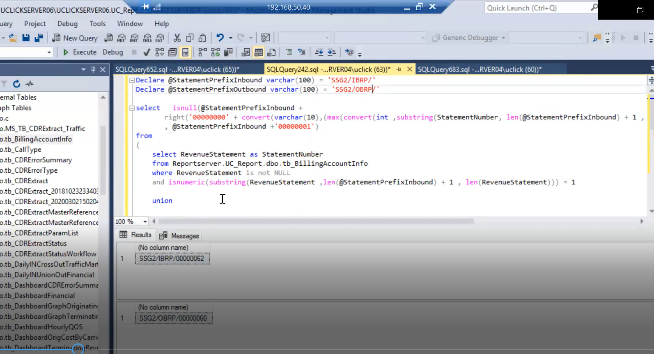

The output will be 2 statement numbers (**SSG2/IBRP/00000062** & **SSG2/OBRP/00000060**) which can be used going forward to generate the statements for Axiata related Parties.

### To generate statement number for Inbound non-related parties, change the first two lines of code as below

Declare @StatementPrefixInbound varchar(100) = 'SSG2/IB/'

Declare @StatementPrefixOutbound varchar(100) = 'SSG2/OB/'

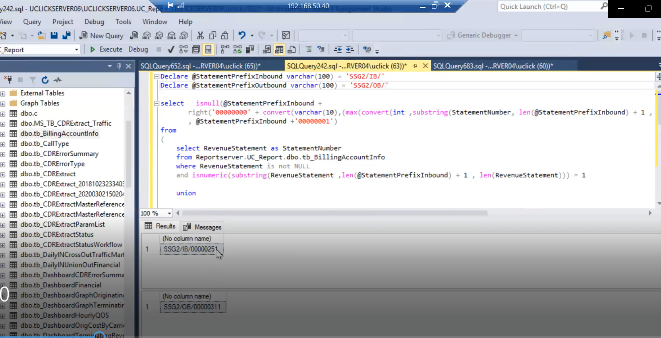

The output will be 2 statement numbers (**SSG2/IB/00000251** & **SSG2/OB/00000311**) which can be used going forward to generate the statements for Axiata Non-related parties.

### To generate statement number for Inbound prepaid, change the first lines of code as below, on the outbound side there will be no statement of usage.

Declare @StatementPrefixInbound varchar(100) = 'SSG2/IB/SOU/'

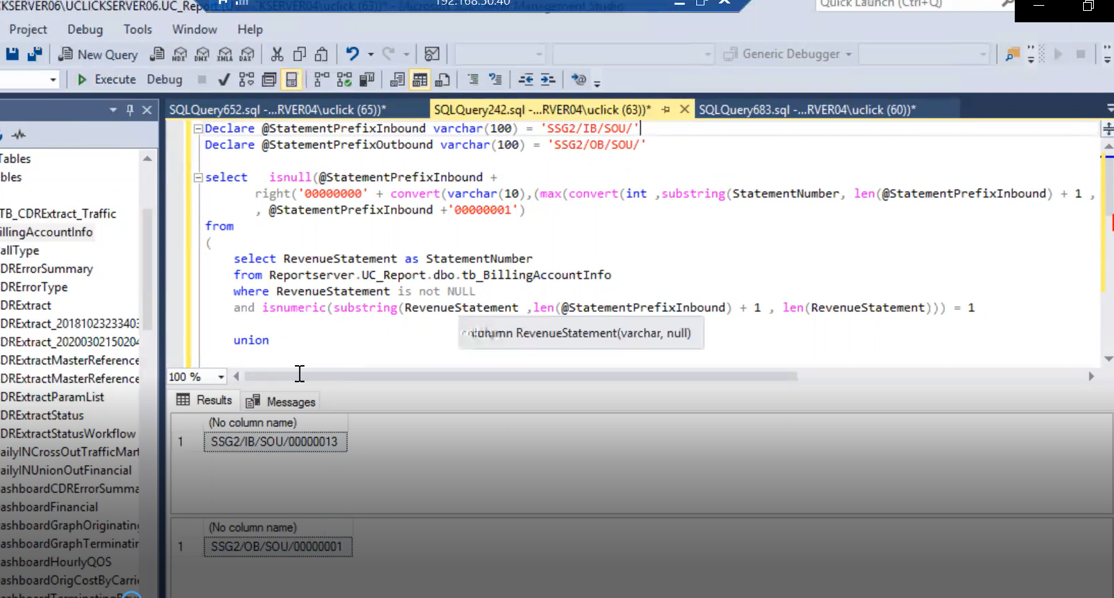

The output will be a statement number (**SSG2/IB/SOU/00000013**) which can be used going forward to generate the SOU statements.

Add a new column Statement number in the inbound sheet to generate the SQL statement to insert xxxxx into the database.

The current starting statement number for **Axiata Related Parties** is **SSG2/IBRP/00000062.**

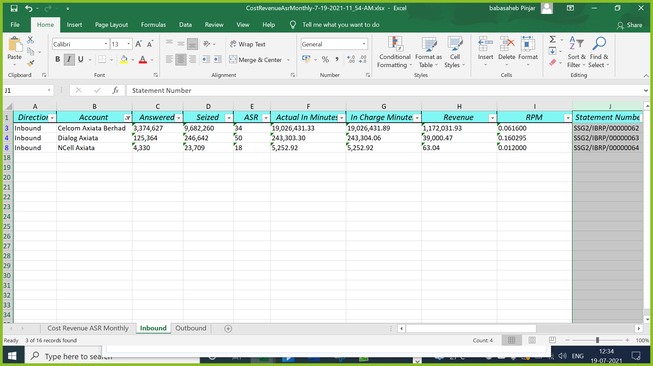

Now, we add the statement numbers for Axiata Non-Related parties which starts from **SSG2/IB/000000251.**

**\*\*** we should not add statement number with IB for prepaid accounts from this sequence, we have to use SOU

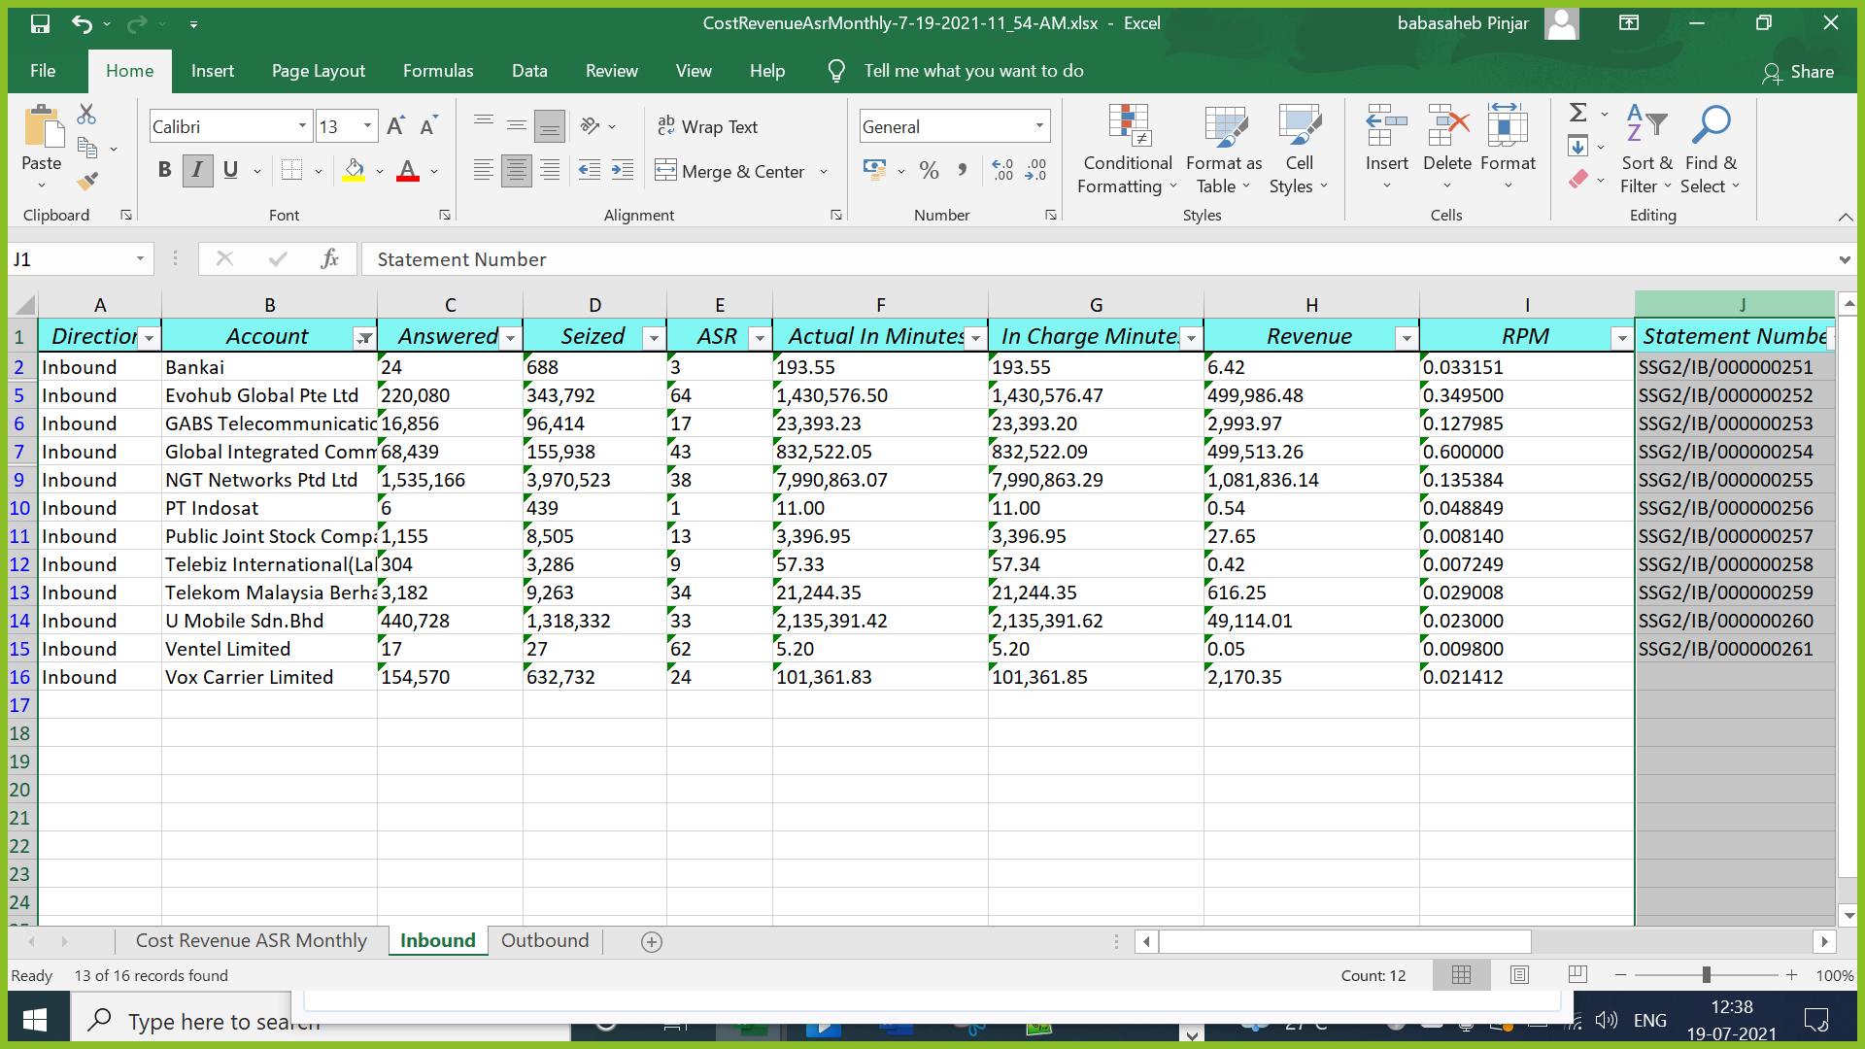

Now, we add the statement numbers for prepaid partner which starts from **SSG2/IB/SOU/00000013.**

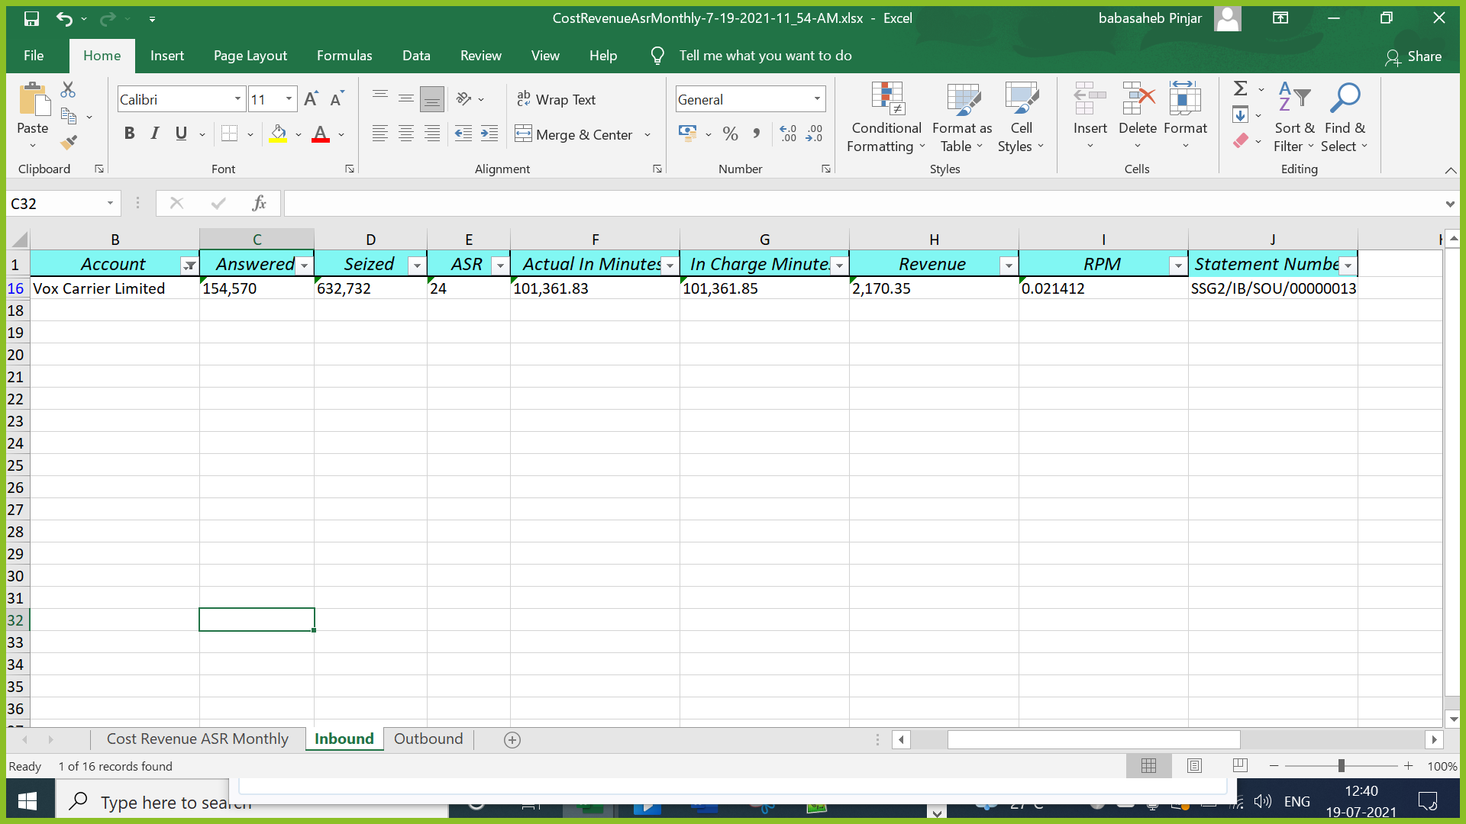

Repeat the same above steps for IBRP and IB for Outbound, on the outbound side we will not differentiate between prepaid and postpaid

Outbound Related Party sequence number: **SSG2/OBRP/00000060**

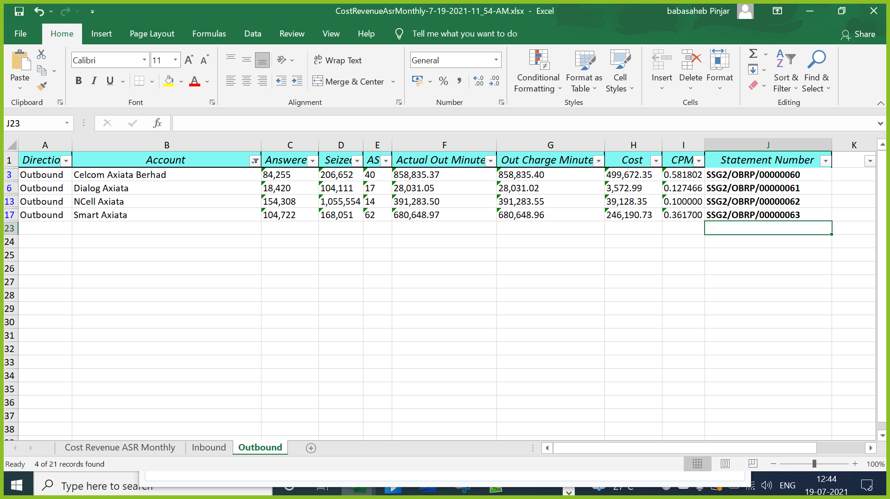

Outbound Non-Related Party sequence number: **SSG2/OB/00000311**

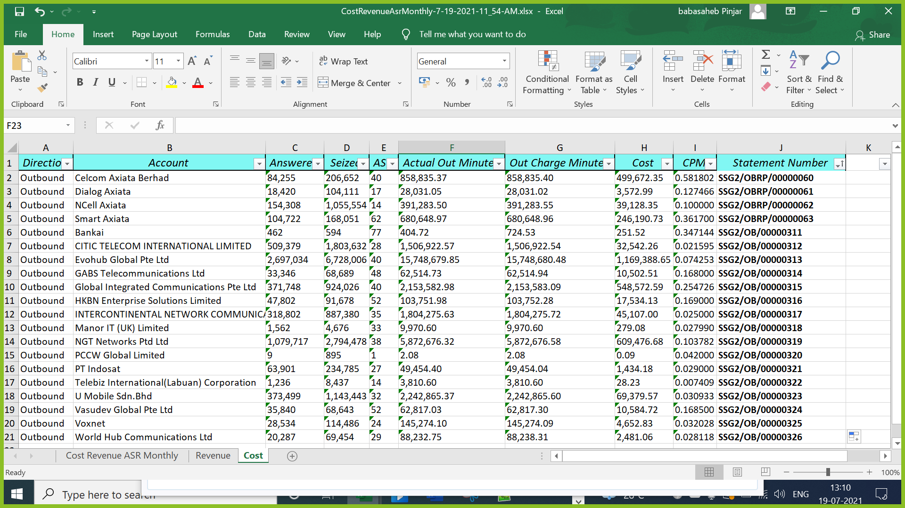

Create a new column (Update Statement) and generate a update statement in both Revenue and Cost sheet.

***update tbl1 set tbl1.RevenueStatement = 'SSG2/IB/000000251' from tb_BillingAccountinfo tbl1 inner join Referenceserver.UC_Reference.dbo.tb_Account tbl2 on tbl1.AccountID = tbl2.AccountID where tbl2.Account = 'Bankai'***

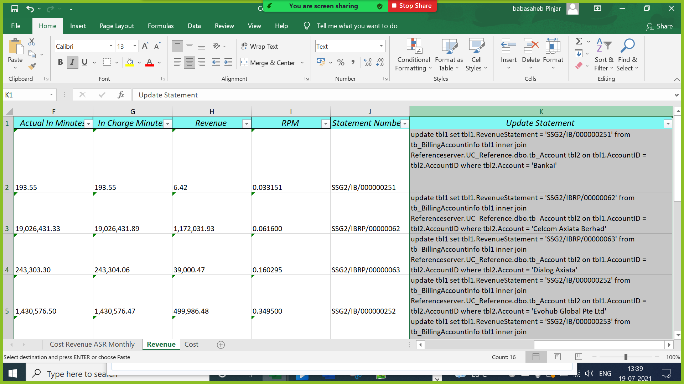

Run the following update command in UC_Report

*update tbl1 set tbl1.RevenueStatement = 'SSG2/IB/000000251' from tb_BillingAccountinfo tbl1 inner join Referenceserver.UC_Reference.dbo.tb_Account tbl2 on tbl1.AccountID = tbl2.AccountID where tbl2.Account = 'Bankai'*

*update tbl1 set tbl1.RevenueStatement = 'SSG2/IBRP/00000062' from tb_BillingAccountinfo tbl1 inner join Referenceserver.UC_Reference.dbo.tb_Account tbl2 on tbl1.AccountID = tbl2.AccountID where tbl2.Account = 'Celcom Axiata Berhad'*

*update tbl1 set tbl1.RevenueStatement = 'SSG2/IBRP/00000063' from tb_BillingAccountinfo tbl1 inner join Referenceserver.UC_Reference.dbo.tb_Account tbl2 on tbl1.AccountID = tbl2.AccountID where tbl2.Account = 'Dialog Axiata'*

*update tbl1 set tbl1.RevenueStatement = 'SSG2/IB/000000252' from tb_BillingAccountinfo tbl1 inner join Referenceserver.UC_Reference.dbo.tb_Account tbl2 on tbl1.AccountID = tbl2.AccountID where tbl2.Account = 'Evohub Global Pte Ltd'*

*update tbl1 set tbl1.RevenueStatement = 'SSG2/IB/000000253' from tb_BillingAccountinfo tbl1 inner join Referenceserver.UC_Reference.dbo.tb_Account tbl2 on tbl1.AccountID = tbl2.AccountID where tbl2.Account = 'GABS Telecommunications Ltd'*

*update tbl1 set tbl1.RevenueStatement = 'SSG2/IB/000000254' from tb_BillingAccountinfo tbl1 inner join Referenceserver.UC_Reference.dbo.tb_Account tbl2 on tbl1.AccountID = tbl2.AccountID where tbl2.Account = 'Global Integrated Communications Pte Ltd'*

*update tbl1 set tbl1.RevenueStatement = 'SSG2/IBRP/00000064' from tb_BillingAccountinfo tbl1 inner join Referenceserver.UC_Reference.dbo.tb_Account tbl2 on tbl1.AccountID = tbl2.AccountID where tbl2.Account = 'NCell Axiata'*

*update tbl1 set tbl1.RevenueStatement = 'SSG2/IB/000000255' from tb_BillingAccountinfo tbl1 inner join Referenceserver.UC_Reference.dbo.tb_Account tbl2 on tbl1.AccountID = tbl2.AccountID where tbl2.Account = 'NGT Networks Ptd Ltd'*

*update tbl1 set tbl1.RevenueStatement = 'SSG2/IB/000000256' from tb_BillingAccountinfo tbl1 inner join Referenceserver.UC_Reference.dbo.tb_Account tbl2 on tbl1.AccountID = tbl2.AccountID where tbl2.Account = 'PT Indosat'*

*update tbl1 set tbl1.RevenueStatement = 'SSG2/IB/000000257' from tb_BillingAccountinfo tbl1 inner join Referenceserver.UC_Reference.dbo.tb_Account tbl2 on tbl1.AccountID = tbl2.AccountID where tbl2.Account = 'Public Joint Stock Company Rostelecom'*

*update tbl1 set tbl1.RevenueStatement = 'SSG2/IB/000000258' from tb_BillingAccountinfo tbl1 inner join Referenceserver.UC_Reference.dbo.tb_Account tbl2 on tbl1.AccountID = tbl2.AccountID where tbl2.Account = 'Telebiz International(Labuan) Corporation'*

*update tbl1 set tbl1.RevenueStatement = 'SSG2/IB/000000259' from tb_BillingAccountinfo tbl1 inner join Referenceserver.UC_Reference.dbo.tb_Account tbl2 on tbl1.AccountID = tbl2.AccountID where tbl2.Account = 'Telekom Malaysia Berhad'*

*update tbl1 set tbl1.RevenueStatement = 'SSG2/IB/000000260' from tb_BillingAccountinfo tbl1 inner join Referenceserver.UC_Reference.dbo.tb_Account tbl2 on tbl1.AccountID = tbl2.AccountID where tbl2.Account = 'U Mobile Sdn.Bhd'*

*update tbl1 set tbl1.RevenueStatement = 'SSG2/IB/000000261' from tb_BillingAccountinfo tbl1 inner join Referenceserver.UC_Reference.dbo.tb_Account tbl2 on tbl1.AccountID = tbl2.AccountID where tbl2.Account = 'Ventel Limited'*

*update tbl1 set tbl1.RevenueStatement = 'SSG2/IB/SOU/00000013' from tb_BillingAccountinfo tbl1 inner join Referenceserver.UC_Reference.dbo.tb_Account tbl2 on tbl1.AccountID = tbl2.AccountID where tbl2.Account = 'Vox Carrier Limited'*

Similarly, do it from Cost Sheet

***update tbl1 set tbl1.CostStatement = 'SSG2/OBRP/00000060' from tb_BillingAccountinfo tbl1 inner join Referenceserver.UC_Reference.dbo.tb_Account tbl2 on tbl1.AccountID = tbl2.AccountID where tbl2.Account = 'Celcom Axiata Berhad'***

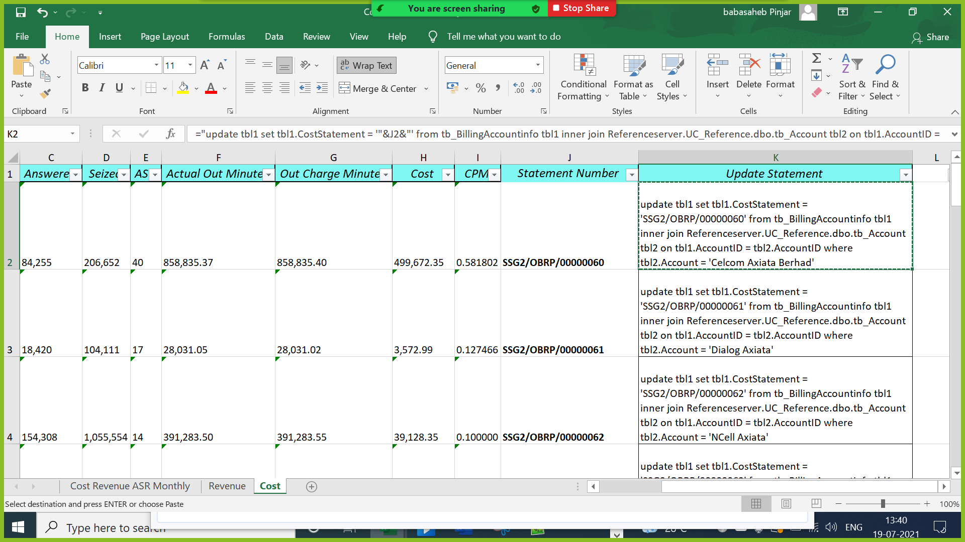

*update tbl1 set tbl1.CostStatement = 'SSG2/OBRP/00000060' from tb_BillingAccountinfo tbl1 inner join Referenceserver.UC_Reference.dbo.tb_Account tbl2 on tbl1.AccountID = tbl2.AccountID where tbl2.Account = 'Celcom Axiata Berhad'*

*update tbl1 set tbl1.CostStatement = 'SSG2/OBRP/00000061' from tb_BillingAccountinfo tbl1 inner join Referenceserver.UC_Reference.dbo.tb_Account tbl2 on tbl1.AccountID = tbl2.AccountID where tbl2.Account = 'Dialog Axiata'*

*update tbl1 set tbl1.CostStatement = 'SSG2/OBRP/00000062' from tb_BillingAccountinfo tbl1 inner join Referenceserver.UC_Reference.dbo.tb_Account tbl2 on tbl1.AccountID = tbl2.AccountID where tbl2.Account = 'NCell Axiata'*

*update tbl1 set tbl1.CostStatement = 'SSG2/OBRP/00000063' from tb_BillingAccountinfo tbl1 inner join Referenceserver.UC_Reference.dbo.tb_Account tbl2 on tbl1.AccountID = tbl2.AccountID where tbl2.Account = 'Smart Axiata'*

*update tbl1 set tbl1.CostStatement = 'SSG2/OB/00000311' from tb_BillingAccountinfo tbl1 inner join Referenceserver.UC_Reference.dbo.tb_Account tbl2 on tbl1.AccountID = tbl2.AccountID where tbl2.Account = 'Bankai'*

*update tbl1 set tbl1.CostStatement = 'SSG2/OB/00000312' from tb_BillingAccountinfo tbl1 inner join Referenceserver.UC_Reference.dbo.tb_Account tbl2 on tbl1.AccountID = tbl2.AccountID where tbl2.Account = 'CITIC TELECOM INTERNATIONAL LIMITED'*

*update tbl1 set tbl1.CostStatement = 'SSG2/OB/00000313' from tb_BillingAccountinfo tbl1 inner join Referenceserver.UC_Reference.dbo.tb_Account tbl2 on tbl1.AccountID = tbl2.AccountID where tbl2.Account = 'Evohub Global Pte Ltd'*

*update tbl1 set tbl1.CostStatement = 'SSG2/OB/00000314' from tb_BillingAccountinfo tbl1 inner join Referenceserver.UC_Reference.dbo.tb_Account tbl2 on tbl1.AccountID = tbl2.AccountID where tbl2.Account = 'GABS Telecommunications Ltd'*

*update tbl1 set tbl1.CostStatement = 'SSG2/OB/00000315' from tb_BillingAccountinfo tbl1 inner join Referenceserver.UC_Reference.dbo.tb_Account tbl2 on tbl1.AccountID = tbl2.AccountID where tbl2.Account = 'Global Integrated Communications Pte Ltd'*

*update tbl1 set tbl1.CostStatement = 'SSG2/OB/00000316' from tb_BillingAccountinfo tbl1 inner join Referenceserver.UC_Reference.dbo.tb_Account tbl2 on tbl1.AccountID = tbl2.AccountID where tbl2.Account = 'HKBN Enterprise Solutions Limited'*

*update tbl1 set tbl1.CostStatement = 'SSG2/OB/00000317' from tb_BillingAccountinfo tbl1 inner join Referenceserver.UC_Reference.dbo.tb_Account tbl2 on tbl1.AccountID = tbl2.AccountID where tbl2.Account = 'INTERCONTINENTAL NETWORK COMMUNICATION LIMITED'*

*update tbl1 set tbl1.CostStatement = 'SSG2/OB/00000318' from tb_BillingAccountinfo tbl1 inner join Referenceserver.UC_Reference.dbo.tb_Account tbl2 on tbl1.AccountID = tbl2.AccountID where tbl2.Account = 'Manor IT (UK) Limited'*

*update tbl1 set tbl1.CostStatement = 'SSG2/OB/00000319' from tb_BillingAccountinfo tbl1 inner join Referenceserver.UC_Reference.dbo.tb_Account tbl2 on tbl1.AccountID = tbl2.AccountID where tbl2.Account = 'NGT Networks Ptd Ltd'*

*update tbl1 set tbl1.CostStatement = 'SSG2/OB/00000320' from tb_BillingAccountinfo tbl1 inner join Referenceserver.UC_Reference.dbo.tb_Account tbl2 on tbl1.AccountID = tbl2.AccountID where tbl2.Account = 'PCCW Global Limited'*

*update tbl1 set tbl1.CostStatement = 'SSG2/OB/00000321' from tb_BillingAccountinfo tbl1 inner join Referenceserver.UC_Reference.dbo.tb_Account tbl2 on tbl1.AccountID = tbl2.AccountID where tbl2.Account = 'PT Indosat'*

*update tbl1 set tbl1.CostStatement = 'SSG2/OB/00000322' from tb_BillingAccountinfo tbl1 inner join Referenceserver.UC_Reference.dbo.tb_Account tbl2 on tbl1.AccountID = tbl2.AccountID where tbl2.Account = 'Telebiz International(Labuan) Corporation'*

*update tbl1 set tbl1.CostStatement = 'SSG2/OB/00000323' from tb_BillingAccountinfo tbl1 inner join Referenceserver.UC_Reference.dbo.tb_Account tbl2 on tbl1.AccountID = tbl2.AccountID where tbl2.Account = 'U Mobile Sdn.Bhd'*

*update tbl1 set tbl1.CostStatement = 'SSG2/OB/00000324' from tb_BillingAccountinfo tbl1 inner join Referenceserver.UC_Reference.dbo.tb_Account tbl2 on tbl1.AccountID = tbl2.AccountID where tbl2.Account = 'Vasudev Global Pte Ltd'*

*update tbl1 set tbl1.CostStatement = 'SSG2/OB/00000325' from tb_BillingAccountinfo tbl1 inner join Referenceserver.UC_Reference.dbo.tb_Account tbl2 on tbl1.AccountID = tbl2.AccountID where tbl2.Account = 'Voxnet'*

*update tbl1 set tbl1.CostStatement = 'SSG2/OB/00000326' from tb_BillingAccountinfo tbl1 inner join Referenceserver.UC_Reference.dbo.tb_Account tbl2 on tbl1.AccountID = tbl2.AccountID where tbl2.Account = 'World Hub Communications Ltd'*

## Generation of Reports

Run ***SP_FinancialReporting_AGS*** procedure to generates 6 reports.

* 1. Traffic Detail
  2. MS Dynamics Inbound Post Paid
  3. MS Dynamics Inbound Pre-Paid
  4. MS Dynamics Outbound Post Paid
  5. MS Dynamics Outbound Pre-Paid
  6. GST Report
  7. ***Prepaid Margin (Comes via mail)***

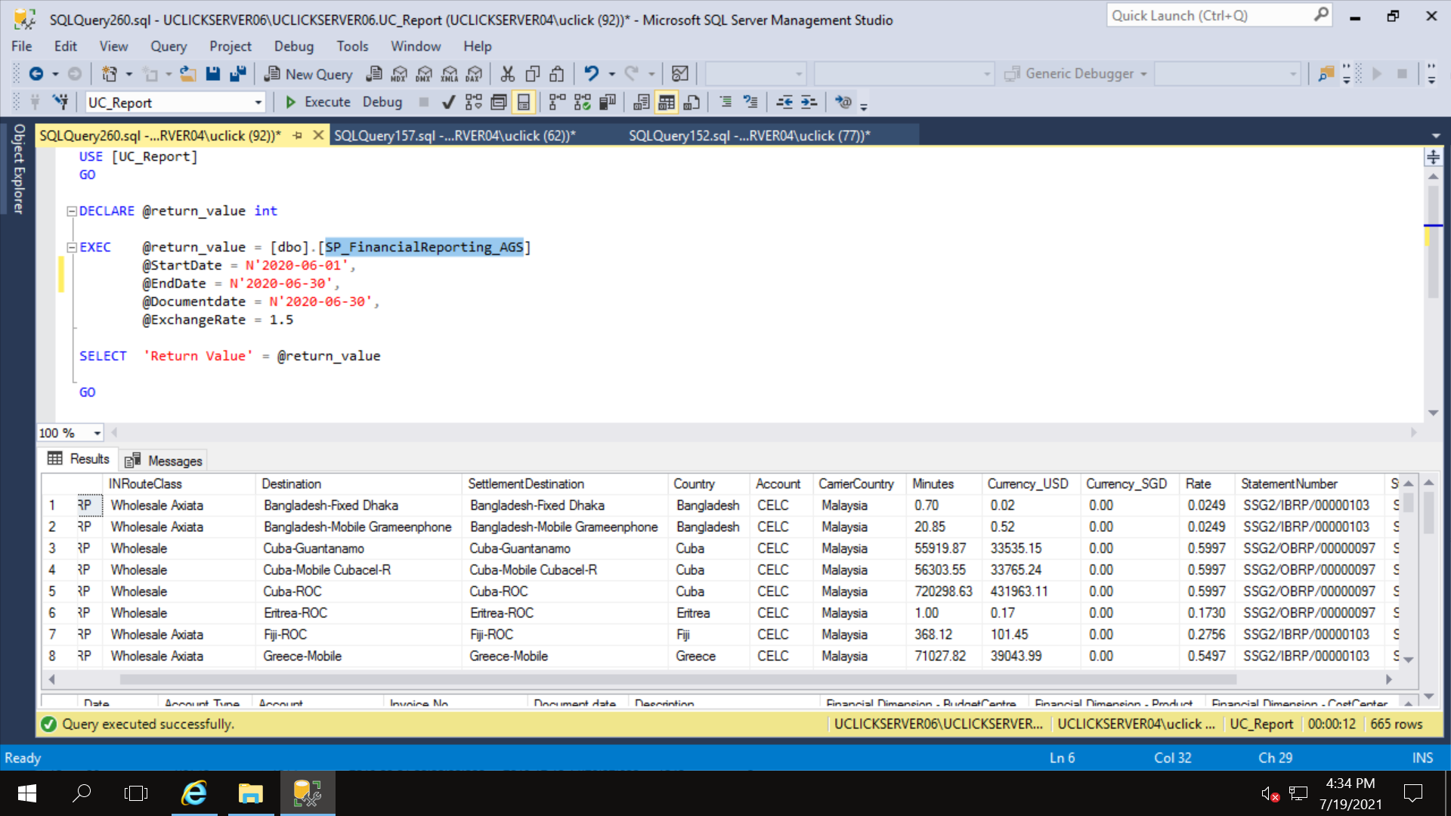

## Generate PDFs